Case Study I: Requirements Analysis

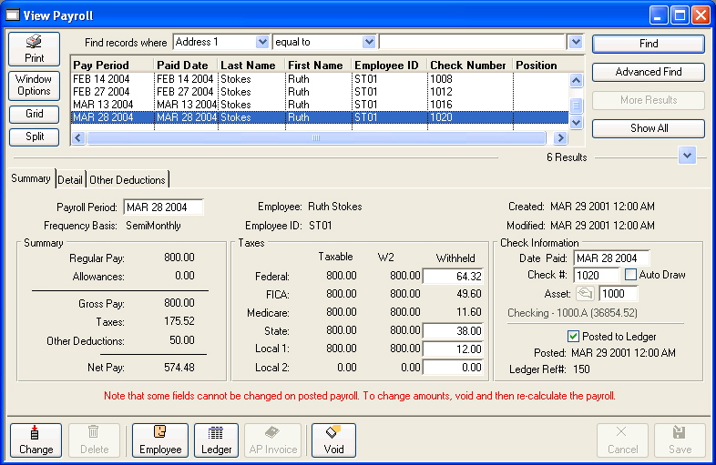
Introduction
This case study will prepare you to develop the final project for this course. The final project for the course will be GUI application for a payroll application. The first step in developing any application is to understand and document the requirements. In this exercise you will work in groups to come up with an initial set of requirements documents. In particular, you should develop
- • A Use case diagram
- • Storyboards for each use case
- • A list of possible domain classes for the project
Distance education students may want to arrange to get together to work on this case study.

Requirements Analysis
You are going to develop an Interactive Payroll Application. The example on the left is a screenshot from one commercial payroll application. This screenshot is shown only as an example. The application that you design will be much simpler.
Your design team has attempted to summarize some of the things that the accountant at Ziggy's Web Development and Scuba Shop has told them. This summary is here. At this point you should not be thinking about the Graphical User Interface, you should be concentrating on the functions that you want to provide in your application. As a group, brainstorm about functions that you might want your application to provide. Keep the list reasonable. Remember that you have to implement them later on. Create a use case diagram that shows all of the functions that your group has come up with.
Now that you have a use case diagram, pick several mainline use cases and storyboard them. Remember that a use case is the sequence of activities that result from some action being taken by one of your actors. For example, what activitites occur when a user selects "Add Employee" from a menu in your application?
After developing several storyboards, go back over your notes and see if you can come up with a set of domain classes for this application. Write down all possibilities, then go through them to identify duplicates. Think about possible inheritance and composition relationships in your classes. Think about what kinds of containers you might need to hold objects in your application and algorithms you might use to manipulate your data.

